Breadth First Search (BFS)

Aim
To implement the Breadth-First Search (BFS) algorithm in Python to traverse all the vertices of a graph level by level.
Algorithm
- Create a graph using an adjacency list.
- Choose a starting node.
- Mark the starting node as visited and insert it into a queue.
- Remove a node from the front of the queue.
- Visit all its unvisited adjacent nodes.
- Mark them as visited and add them to the queue.
- Repeat Steps 4–6 until the queue becomes empty.
Python Code
from collections import deque

# Input number of vertices
n = int(input("Enter the number of vertices: "))

graph = {}

# Input adjacency list
for i in range(n):
vertex = input(f"Enter vertex {i+1}: ")
neighbours = input(f"Enter neighbours of {vertex} (space-separated): ").split()
graph[vertex] = neighbours

start = input("Enter the starting vertex: ")

def bfs(graph, start):
visited = set()
queue = deque([start])
visited.add(start)

print("\nBFS Traversal:")

while queue:
node = queue.popleft()
print(node, end=" ")

for neighbour in graph[node]:
if neighbour not in visited:
visited.add(neighbour)
queue.append(neighbour)

bfs(graph, start)

Output
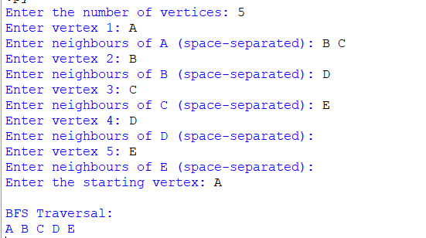

Result
The Breadth-First Search (BFS) algorithm was successfully implemented in Python. The program traversed the graph level by level using a queue and visited all the vertices successfully.

